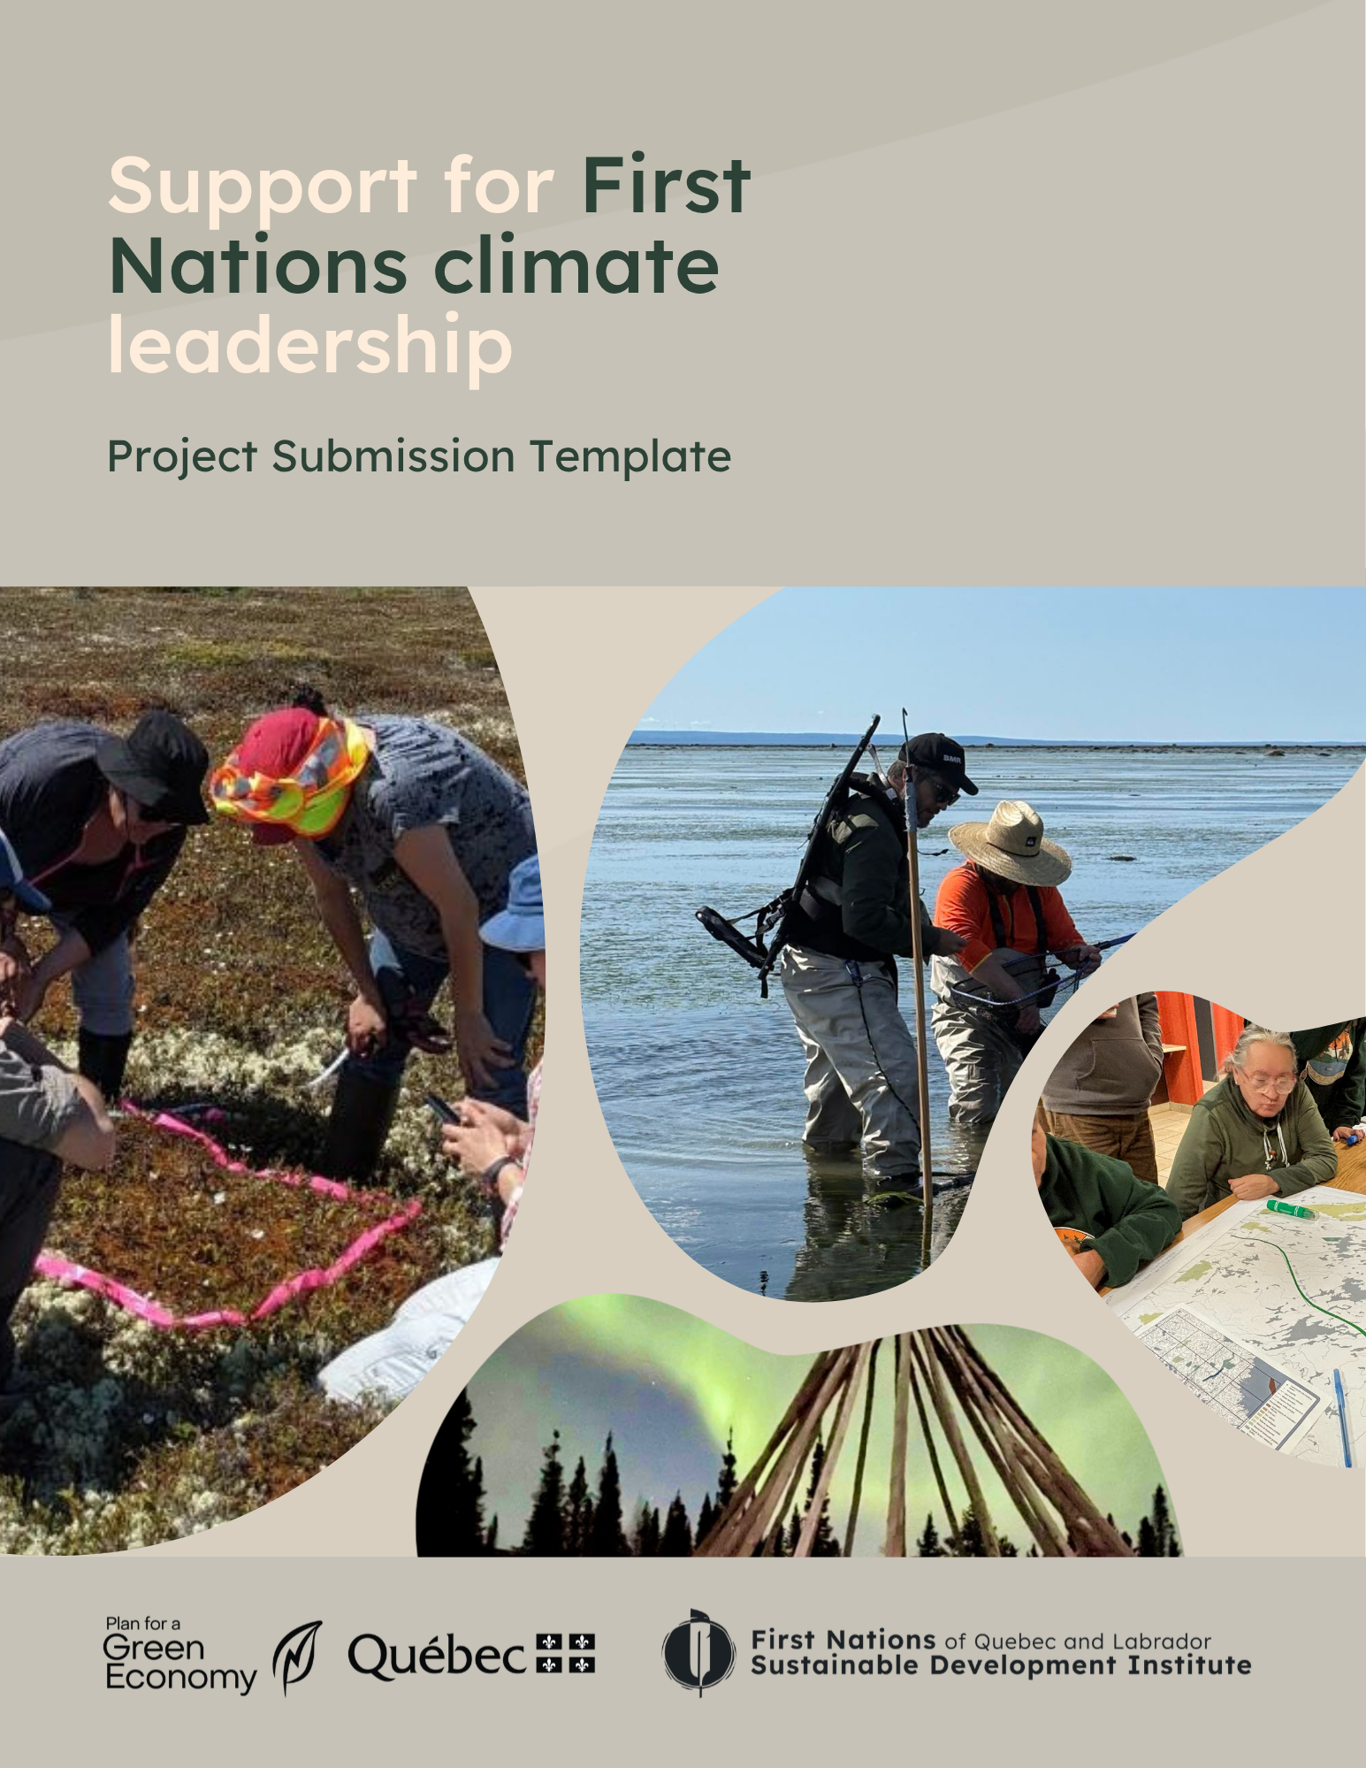

The Support for First Nations Climate Leadership initiative is funded by the Government of Quebec as part of the 2030 Plan for a Green Economy (2030 PGE). It aims to support First Nations community projects to strengthen their leadership in the climate transition.

Purpose of the Project Submission Template
The purpose of this document is to provide an example of what a project proposal submitted under the Support for First Nations Climate Leadership initiative might look like. You may use this template or another format that better suits your needs.
Once projects are deemed eligible, they will undergo the project selection process in accordance with the selection committee’s recommendations. A list of selection criteria is provided in Schedule A. Prioritization criteria (see Schedule B), previously determined by the selection committee, may be used to break ties among projects with equal scores. Otherwise, prioritization criteria will not be considered during the project evaluation.

Your Project Proposal Must Include the Following Elements:
- Information about the project leader and a summary of the project
- Information about the project
- Work plan and tentative timelines
- Information about the project team
- Information about external partners, if applicable
- Preliminary budget

Need Support or Answers to Your Questions?
Our climate change team is here for you! Whether you have questions, want to explore a project idea, or need more in-depth support, we’re here to help.
Feel free to contact us, no matter where you are in the planning process.

📧financement@iddpnql.ca Please include “Support for First Nations Climate Leadership” in the subject line of your email.

📞 418-843-9999 — ask for Laura Normandin-Bellefeuille or Thomas Goudreault.

Project Submission Format
It is recommended that you submit your project proposal in Word format, with a maximum total length of 20 pages (excluding images). Regardless of the format you choose, be sure to address the topics covered in the questions below.

1. Information About the Project Leader and a Summary of the Project
Project Leader
(name of the organization)

Address and ZIP code

Name of Contact Person(s) | Add multiple contacts if applicable
Title/Position of the Contact Person(s)
Contact Information | Email address and phone number

Project Title

Application Submission Date

Amount Requested
Estimated Project Dates
Project Location | If possible, identify the location(s) where the project activities will take place
Project Summary | Outline the project, its objectives, and its main activities

2. Project Information
Below are a few questions related to the selection criteria for your project.

2.1 Context and Background
Briefly explain the context of your project.

Your text here:

Why is this project important to your community or organization? What needs and priorities does it address?

Your text here:

Is this project a continuation of a previous project? If so, briefly explain the previous project and how it relates to your project.
Your text here:

2.2 Description of the Project and Its Objectives
What are the short-term and long-term objectives of your project?
Your text here:

2.3 Link to Climate Change
Mitigation

All actions aimed at limiting climate change, primarily by reducing greenhouse gas emissions from sources and increasing removals by sinks.

Adaptation

All measures designed to limit the impacts of climate change or to take advantage of the benefits it brings.

Identify the theme(s) addressed by your project.
Check one or more boxes
☐ Support climate change adaptation efforts
☐ Support climate change mitigation efforts
☐ Engage individuals, facilitate knowledge transfer, and/or create outreach opportunities for your community, organization, or First Nations in the context of climate change

Briefly explain how the project will contribute to the identified themes.

For adaptation, please explain how your project will address the impacts of climate change already being felt and those anticipated in the future.

For mitigation, please explain how your project will pay particular attention to assessing the potential for reducing greenhouse gas emissions.

Contact us if you have any questions!
Your text here:

2.4 Capacity Building and Participatory Approach
Explain how your project will involve your community, your organization, or First Nations members, considering an inclusive approach that takes into account different population groups.

Your text here:

Explain how your project will help build the capacity, knowledge, and/or skills of your community, your organization, or First Nations.
Your text here:

2.5 Valuing of Indigenous Knowledge and/or Languages
Explain how Indigenous knowledge and/or languages will be valued as part of your project.

Your text here:

2.6 Project Deliverables, Outcomes, and Communications
Identify the anticipated impacts and deliverables of your project.
Impacts: The medium-term or long-term benefits for the individuals, communities, or environments targeted by the project (e.g., improved knowledge, capacity building, reduced climate risks, etc.)
Deliverables: Specific products or services resulting directly from the project’s activities (e.g., reports, tools, guides, training, data, etc.)
Your text here:

Describe how you will publicize and promote the project’s impacts to your community, partners, and interested stakeholders.
Your text here:

2.8 Additional Information (optional)
Would you like to share any other details about your project?
Please note any other comments or specifications you’d like to share about your project. You may also send us additional attachments as needed.
Your text here:

3. Work Plan and Tentative Timelines
Fill out the table with the major milestones, activities, timelines, expected results, and deliverables.
You can add rows as needed.
Please note that this table is provided as a tool; you may share this information with us in whatever format works best for you.

Key Milestones |  | Description of Activities | Estimated Timeline | Anticipated Results and Deliverables
The following three activities are provided as examples of a work plan.
1 | Project Coordination | Hire and train a project manager | Summer 2026 | - Employee hired and trained
2 | Gathering  Knowledge | Conduct a literature review and interviews with Elders to develop climate indicators | September 2026 | - Literature review completed  - Interviews with Elders completed
3 | Reporting | Drafting of the final report for the FNQLSDI | March 2027 | - Submission of the report and presentation of the results
1

2

3
4
5
6

4. Project Team Information
Fill out the table with information about each member of the project team. If you do not yet know who the project team members will be, you can indicate “to be determined” and explain how you plan to select them.
Contributing partners are not required. However, if your organization is contributing to your project, indicate this in the “Role in the Project” column and include it in the budget.
You can add rows as needed.
Name and Title | Organization | Role in the Project

5. Information on External Partners
If applicable, provide details about the partners involved in the project (e.g., university teams, consultants, nonprofit organizations, municipalities, etc.).

You can add rows as needed.
The “Description of Participation” column is used to specify the contribution made (in cash or in kind).
Cash: financial contribution to the project
In-kind: non-monetary contribution (e.g., work time, expertise, equipment, or use of facilities)
Name and Title | Organization | Role in the Project | Contribution In Cash or In Kind?
Support

The FNQLSDI can also provide support for your project. Contact us to discuss your needs!

6. Budget

You can find a budget template to fill out in Excel format by clicking here. It is also available on the Fund’s webpage.

Contributions from partners and any other sources of funding for your project must be included in the budget template, specifying whether they are cash or in-kind contributions.

SCHEDULE A

Selection Criteria
The selection criteria will guide the selection committee’s analysis and evaluation of project proposals.
1. Coherence of the Project Proposal
☐ The context is clearly defined
☐ The objectives are relevant and realistic
☐ The selection criteria are met
☐ The provisional work plan, timeline, and budget are coherent and realistic
2. Project Deliverables, Outcomes, and Communications
☐ The deliverables are consistent with and realistic given the project’s objectives
☐ The project’s impacts are relevant to this funding initiative
☐ The project’s communications and outreach are clearly defined
3. Link to Climate Change
The project addresses one (or more) of the following themes:

☐ The project supports climate change adaptation efforts
☐ The project supports climate change mitigation efforts
☐ The project mobilizes, facilitates knowledge transfer, and/or promotes your community’s or organization’s work on climate change
4. Community Priorities
☐ The project demonstrates that it addresses the needs and priorities of the community or First Nations
☐ For organizations that are not band councils, a letter of support from the community or communities targeted by the project is required to demonstrate that it addresses a priority of the First Nation(s)
5. Capacity Building and Participatory Approach
☐ The project demonstrates ownership by the organization or community leading the project
☐ The project demonstrates that it promotes capacity building among First Nations
☐ The project demonstrates a participatory approach, particularly through the involvement and mobilization of community or First Nations members
6. Valuing of Indigenous knowledge and/or Languages
☐ The project demonstrates a commitment to valuing Indigenous knowledge and/or languages

SCHEDULE B

Prioritization Criteria
The prioritization criteria, chosen by the selection committee, will be used only to determine the ranking between projects in the event of a tie in scoring during the selection process.
The criteria, in order of priority, are as follows:
1. Urgency of action: for example, depending on community needs, a project related to flood adaptation might take priority over a climate monitoring project.
2. Type of applicant: Projects submitted by a band council from one of the 31 eligible First Nations communities will be prioritized.
3. Capacity building: A project that places a strong emphasis on building local capacity will be prioritized.
4. Collaboration among communities: A project that facilitates the sharing of knowledge or tools with other communities and/or benefits other communities and/or promotes better collaboration among communities will be prioritized.



174, Chef-Aimé-Romain
Wendake, (Quebec)
G0A 4V0

418-843-9999
418-843-3625
info@iddpnql.ca
www.FNQLSDI.ca

