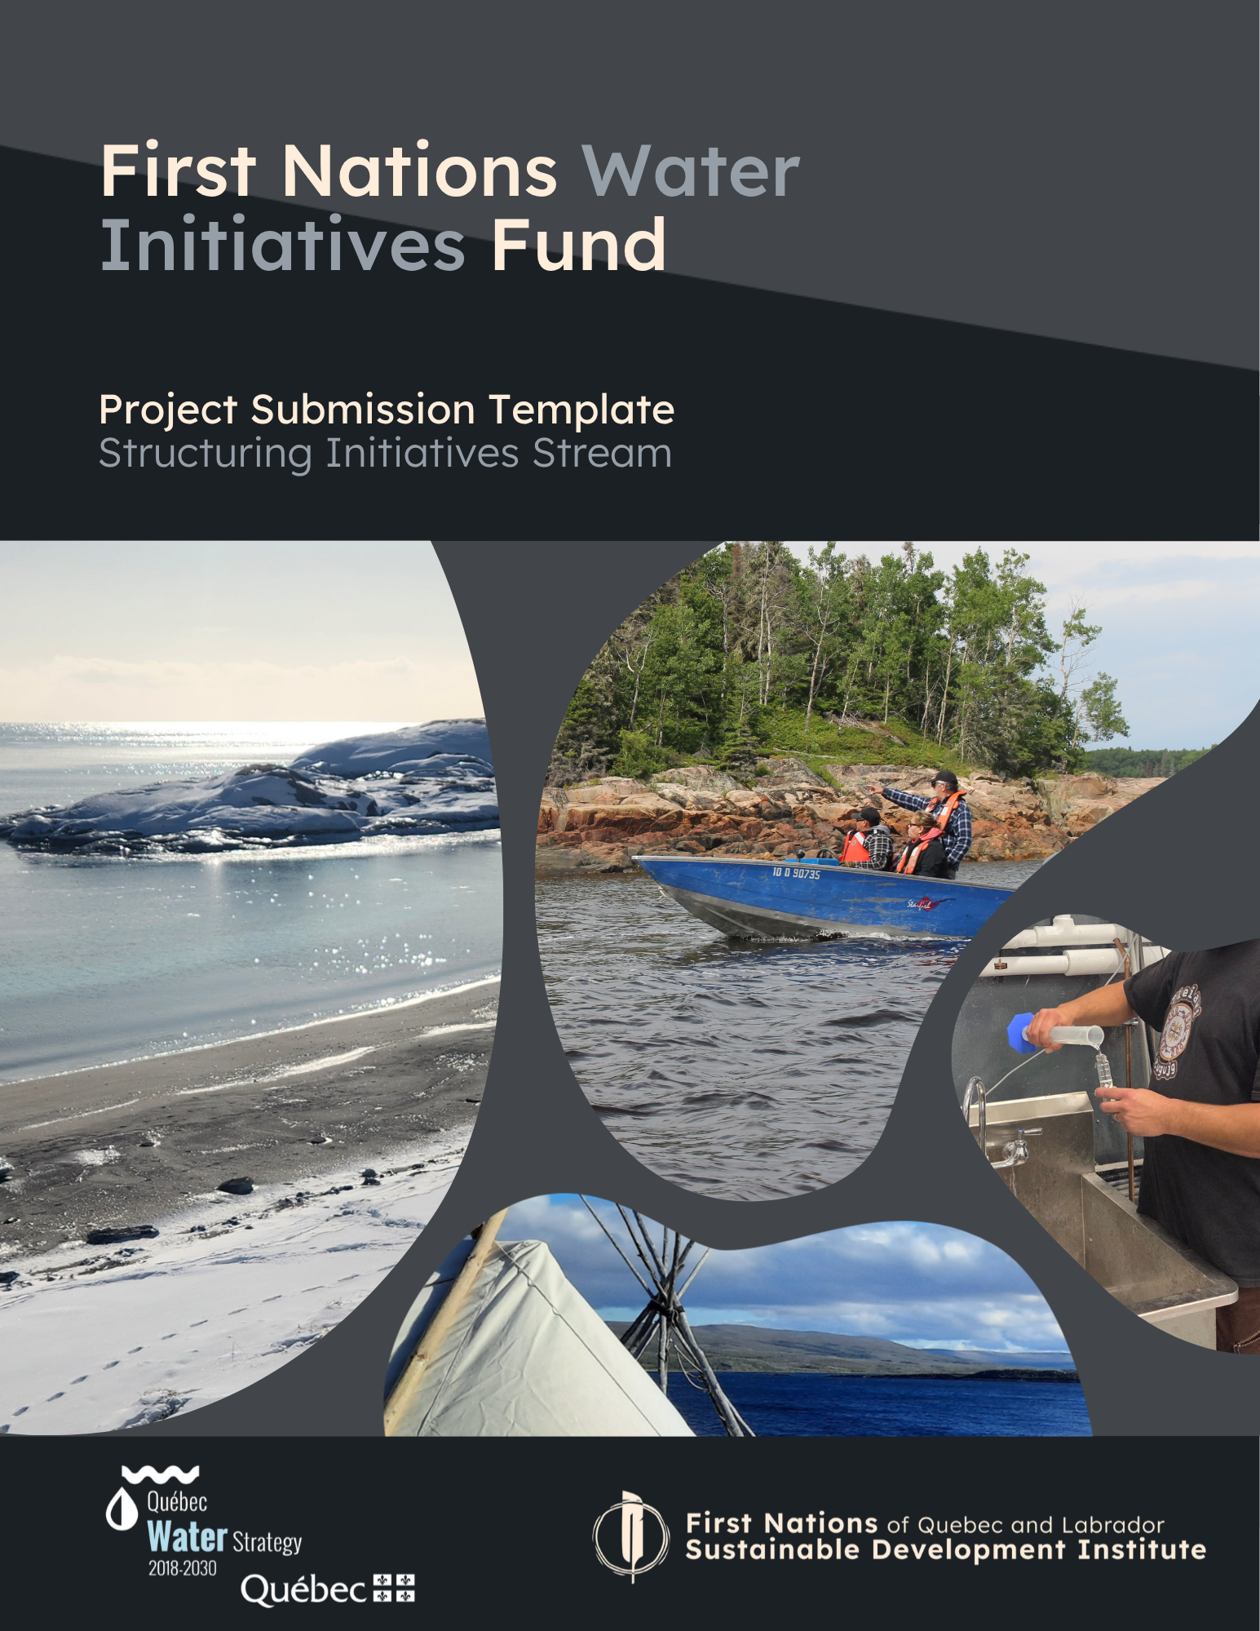

Table of Contents
1. Project Leader Information and Summary of the Project 2
2. Eligibility Criteria Checklist 3
3. Project Details 4
3.1 Background and History 4
3.2 Link(s) with the Plan national de l’eau’s Orientations 4
3.3 Objectives 5
3.4 Participatory Approach and Capacity Building 5
3.5 Valuing Indigenous Knowledge and/or Languages 5
3.6 Outcomes and Benefits 5
3.7 FNQLSDI Implication 6
3.8 Other Details 6
4. Work Plan and Timeline 7
5. Project Team Information 8
6. External Partners Information 8
7. Budget 9

The First Nations Water Initiatives Fund is financed by the Blue Fund. The latter is part of the Plan national de l’eau of the Québec Water Strategy, which implements concrete measures to protect and manage water as well as aquatic environments in a responsible, integrated, and sustainable manner.
Purpose of the Project Submission Template
This document provides an example of the structure of a project proposal that could be submitted to the First Nations of Quebec and Labrador Sustainable Development Institute (FNQLSDI) under the First Nations Water Initiatives Fund. The use of this template is strongly recommended, but not mandatory. Thus, we will accept any format that allows us to understand your project.
Your project proposal must contain the following:
- Information on the project leader
- Project details
- Draft work plan and timeline
- Project team information
- Information on external partners, if applicable
- Preliminary budget
- Optional: letters of support from partners (financial or otherwise)

Projects received through the call for projects under the Fund’s Structuring Initiatives stream must meet the eligibility criteria, but also be subject to the project selection process, in accordance with the recommendations of the Fund’s Strategic Committee. Please note that project proposals received may be shared with the Government of Quebec but will remain confidential.
For more details on eligible projects, refer to the Applicant’s Guide available on the Fund’s web page.
Please note that your project proposal may be considered under another of our current or future funds.
If this is the case, our team will be in touch to inform you.
Other FNQLSDI Funding Opportunities

Need Help?
We can support communities and organizations eligible for the Fund in their efforts if they feel the need. Whether it is to develop and prepare your project proposal, or for support during the realization of your project, we are available for you.
For more information about support or any other questions about the Fund, please contact Julie-Christine Martin, Environmental Project Leader, at funding@iddpnql.ca, mentioning the First Nations Water Initiatives Fund in the subject line of the email.
You can also contact us by phone at 418-843-9999 and ask to speak to Julie-Christine. We will be happy to answer your questions and discuss your project, concerns or ideas.

1. Project Leader Information and Summary of the Project
Project Leader
(organization name)
Address and Postal Code

Contact Name | Add multiple contacts if necessary
Title/Position of Contact Person(s)
Contact Information | Contact email address and phone number

Project Title

Submission Date
Amount Requested
Estimated Project Dates
Project Location | Identify the location(s) where project activities will take place
Project Summary | Present the outline of the project, its objectives and main activities (max. 200 words)

2. Eligibility Criteria Checklist
Please check that your application is complete and meets the following eligibility criteria:

☐ The applicant is a First Nation band council OR an Indigenous non-profit organization that is not from the Cree or Naskapi Nations (these nations have separate agreements with the provincial government).
☐ The proposal is complete:
☐ The project answers to at least one orientation of the Plan national de l’eau and this orientation is identified.
☐ A preliminary work plan with realistic timelines is provided.
☐ A realistic preliminary budget is provided.
☐ The amount requested is equal to or less than the maximum established for Structuring Initiatives, i.e. $490,000.
☐ If a consultant or private company (Indigenous or non-Indigenous) is involved in more than 40% of the total project budget, the application clearly explains how community capacity building will be implemented and/or how the project addresses a priority community need.
The project:
☐ Can be completed before March 31, 2029.
☐ Respects the eligible expenses under the Fund.
☐ Does not fund the organization's regular activities and operations.
☐ Does not aim to create a foundation.
☐ Does not include lobbying activities.
☐ Does not involve the financing of collective wastewater and drinking water infrastructure or the acquisition of land and buildings.
☐ Did not start before the proposal was submitted, unless the project proposal allows for a new phase to begin.
For more details on eligible projects and selection criteria, refer to the Applicant’s Guide.
The project proposal must be submitted to funding@iddpnql.ca by September 18, 2026, with the First Nations Water Initiatives Fund in the subject line.
Proposals submitted under the Structuring Initiatives stream will be analyzed after the project submission deadline. Our team will provide responses to applicants within a reasonable delay following the submission deadline.

To Send Us Your Proposal

3. Project Details
Below are some questions related to the selection criteria for your project. Regardless of the format you choose to submit your proposal, be sure to answer the themes of the questions asked here.
The number of words for each section to be completed is indicated as a suggestion.
Try to remain concise, while providing a complete and precise answer to facilitate our understanding of your project.

3.1 Background and History
Briefly explain the context and background of the project (max. 200 words):

Why is this project important to the community? What needs and priorities does it address? Are other similar or complementary initiatives already underway on your land? (max. 200 words)

Is this a continuation of a previous project? If yes, briefly explain the previous project and the link to the project presented. (max. 200 words)

3.2 Link(s) with the Plan national de l’eau’s Orientations
Identify the orientation(s) of the Plan national de l’eau targeted by your project.
Check one or more boxes
☐ Ensuring quality water for the population
☐ Protecting and restoring aquatic environments
☐ Preventing and managing water-related risks
☐ Capitalizing on the economic potential of water
☐ Promoting sustainable water use
☐ Acquiring and sharing the best knowledge about water
☐ Ensuring and strengthening integrated water resources management

Briefly explain how the project will contribute to the identified orientations (max. 300 words):

3.3 Objectives
What are the short-term and long-term objectives of the project? (max. 300 words)
To make it easier to track your project, make sure your goals are specific, measurable, achievable, realistic, and time bound.

3.4 Participatory Approach and Capacity Building
Explain how your project will involve your community (max. 200 words):

Explain how your project will support the development of capacity, knowledge and/or skills in your community or organization (max. 200 words):

3.5 Valuing Indigenous Knowledge and/or Languages
Explain how Indigenous knowledge and/or languages will be valued in your project (max. 300 words):

3.6 Outcomes and Benefits
Identify the deliverables and expected benefits of your project (max. 300 words):

Will your project contribute to creating economic benefits for the community (e.g., job creation, income from tourism activity, etc.)? If yes, name the expected economic benefits. (max. 200 words)

Identify how you will promote the project to your community, partners and contributors (max. 200 words):

3.7 FNQLSDI Implication
This section will allow us to assess your needs for collaboration with the FNQLSDI team.
This contribution can be integrated into the budget template by adding in-kind amounts in the "Partner Contribution" columns. An in-kind amount is a contribution to which a monetary value is associated, such as time or equipment loan.

Does your project require support from the FNQLSDI team for its implementation stages?
☐ Yes
☐ No
☐ I don’t know
What expertise(s) would you need from the FNQLSDI?
☐ Project management (e.g., grant writing, planning, progress monitoring, reporting, etc.)
☐ Biodiversity or conservation (e.g., inventories and monitoring of fauna and/or flora, aquatic restoration, etc.)
☐ Climate change and energy (e.g., risk prevention, erosion, flooding, etc.)
☐ Environment (e.g., contamination management, environmental analysis, water quality monitoring, hydrogeology, etc.)
☐ Geomatics (e.g., map development, creation and use of GPS tools, etc.)
☐ Other: __________________________________
☐ I don't know
Briefly describe your needs in relation to the FNQLSDI 's expertise? (max. 200 words)

3.8 Other Details
Do you want to share more details about your project?
Write down any other comments or specifications you'd like to share about your project here. You can also send us additional attachments if needed.

4. Work Plan and Timeline
Complete your project work plan table with the planned steps, activities, timelines, results and deliverables. The work plan helps illustrate how you will achieve your goals.
You can insert additional rows into the table as needed.

Please note that this table is available as a tool, you can share this information with us in the format that suits you best.
Major Steps |  | Description of Activities | Estimated Timeline | Anticipated Results and Deliverables
Example
1 | Project coordination | Hire and train a Project Manager | Summer 2026 | - Employee hired and trained
2 | Collection of  Knowledge | Conduct a literature review and interviews with Elders to establish a portrait of waterways | September 2026 | - Literature review  Completed  - Interviews with Elders conducted
3 | Reporting | Drafting of the annual report for the FNQLSDI | March 2027 | Report submitted and presentation of the results
1

2

3
4
5
6

5. Project Team Information
Complete the table with information about each member of the project team. If you are not sure who the team members will be yet, you can indicate " to be determined" and briefly explain how you will go about appointing them.
You can insert additional rows into the table as needed.

Please note that this table is available as a tool, you can share this information with us in the format that suits you best.
Name and Title | Organization | Role in the Project

6. External Partners Information
If applicable, provide details on any other partners who will be involved in the project (e.g., university teams, consultants, non-profit organizations, municipalities, etc.).
You can insert additional rows into the table as needed.

Please note that this table is available as a tool, you can share this information with us in the format that suits you best.
Name and Title | Organization | Role in the Project | Nature of the Contribution

7. Budget

You can find the budget template in Excel format on the First Nations Water Initiatives Fund’s web page by clicking here.
Don't forget to send us your budget template when sending your project proposal and to specify any other sources of funding for your project.



info@iddpnql.ca
www.iddpnal.ca

418 843-9999
418 843-3625
174, Chef-Aimé-Romain
Wendake, (Québec)
G0A 4V0

